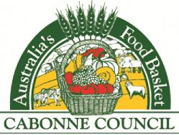
Phone: | 02 6390 7100 | THE GENERAL MANAGER  POST OFFICE BOX 17 | Doc ID: 1012728
Fax: | 02 6392 3260 | MOLONG 2866 | Your Ref:
Contact: | Engineering Dept | Website: www.cabonne.nsw.gov.au | ABN: 41992 919 200
 |  | Email: council@cabonne.nsw.gov.au

18 June 2019
CONTRACT 1008628 – CONSTRUCTION OF TRUCK WASH FACILITY
MOLONG NSW 2866
ADDENDUM TWO
Please note that Council has extended the closing date for the above Contract. It will now close WEDNESDAY 31 JULY 2019 at 12noon.
Council needs to review the design of the truck wash facility. Council will upload the revised design as soon as it becomes available.
We apologise for any inconvenience.
If you have any queries regarding this, please contact Council’s Engineering Department on 02 6390 7100.

