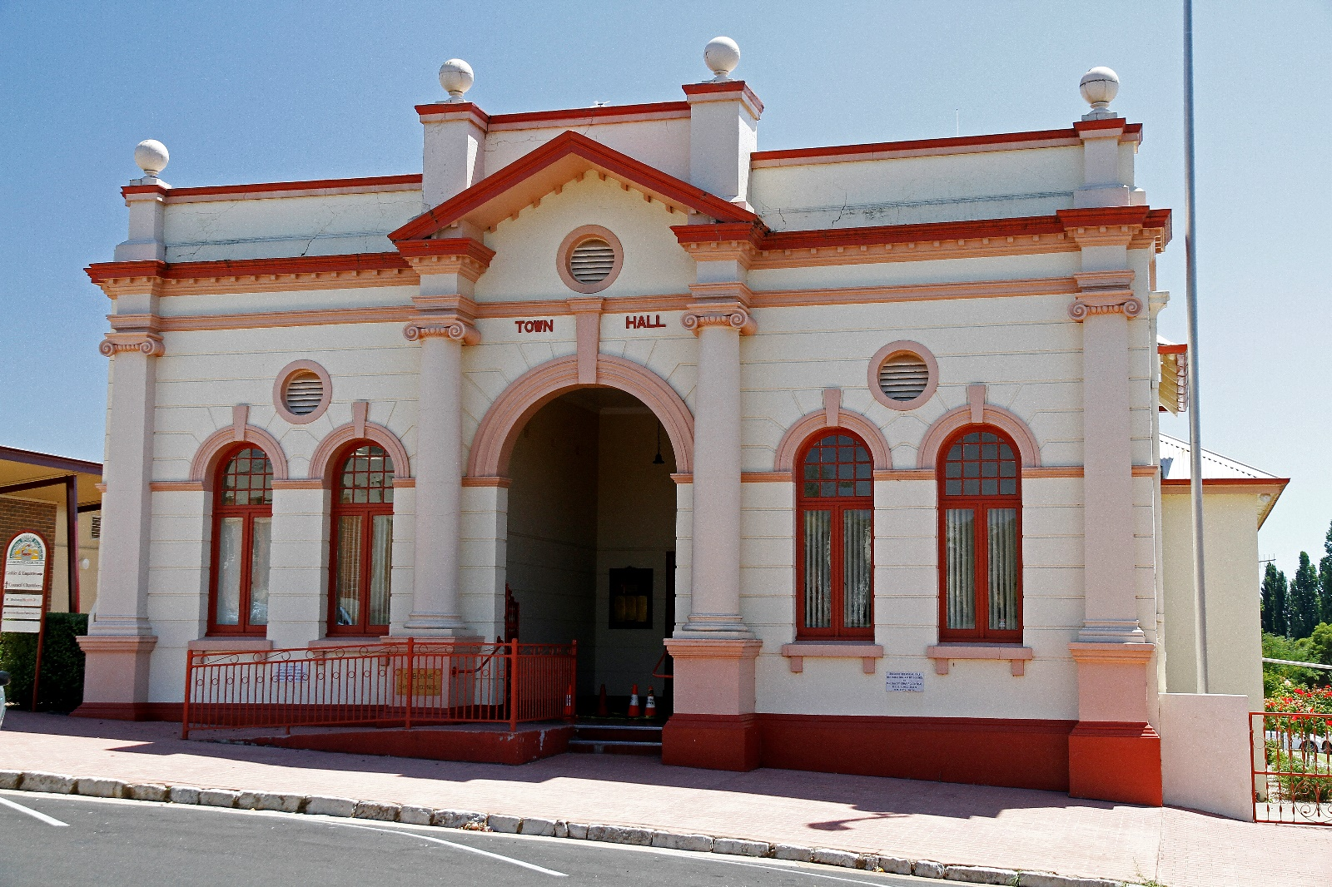

Contract 1033172 - Project Management Services

Addendum One

SCHEDULES FOR COMPLETION

SCHEDULE A – PRIMARY PROJECTS

TO BE COMPLETED BY CONTRACTOR

Name of person, firm or company Tendering:
hereby quote to perform the works for: |  | Project Management Services – Primary Projects (PP)
All Goods and Services Tax is to be included separately in the specified "GST" line item.
Note: Costs can be broken down into the four project states or an overall total sum can be provided.
ITEM  NO | ITEM DESCRIPTION |  | Estimated  QTY | UNIT |  | RATE $/UNIT |  | AMOUNT $
PP-1 | Molong Community Hall, Library & Community Learning Centre |  |  | Hours
PP-2 | Eugowra Puzzle Flat Creek Flood Levee |  |  | Hours
Sub-total excluding GST (A)
GST (B)
Total (A) + (B)
Disbursements (estimated) |  |  |  |  |  |  | Rate  (Including GST)

SCHEDULE B – FEES

Name of person, firm or company Tendering:
hereby quote to perform the works for: | Project Management Services – Subsidiary Projects (SP)
All Goods and Services Tax is to be included separately in the specified "GST" line item.
Outline the list of fees charged in the delivery of additional projects (outside the scope of the two principle projects).

Base hourly rate (GST inclusive)

Travel

Disbursements

