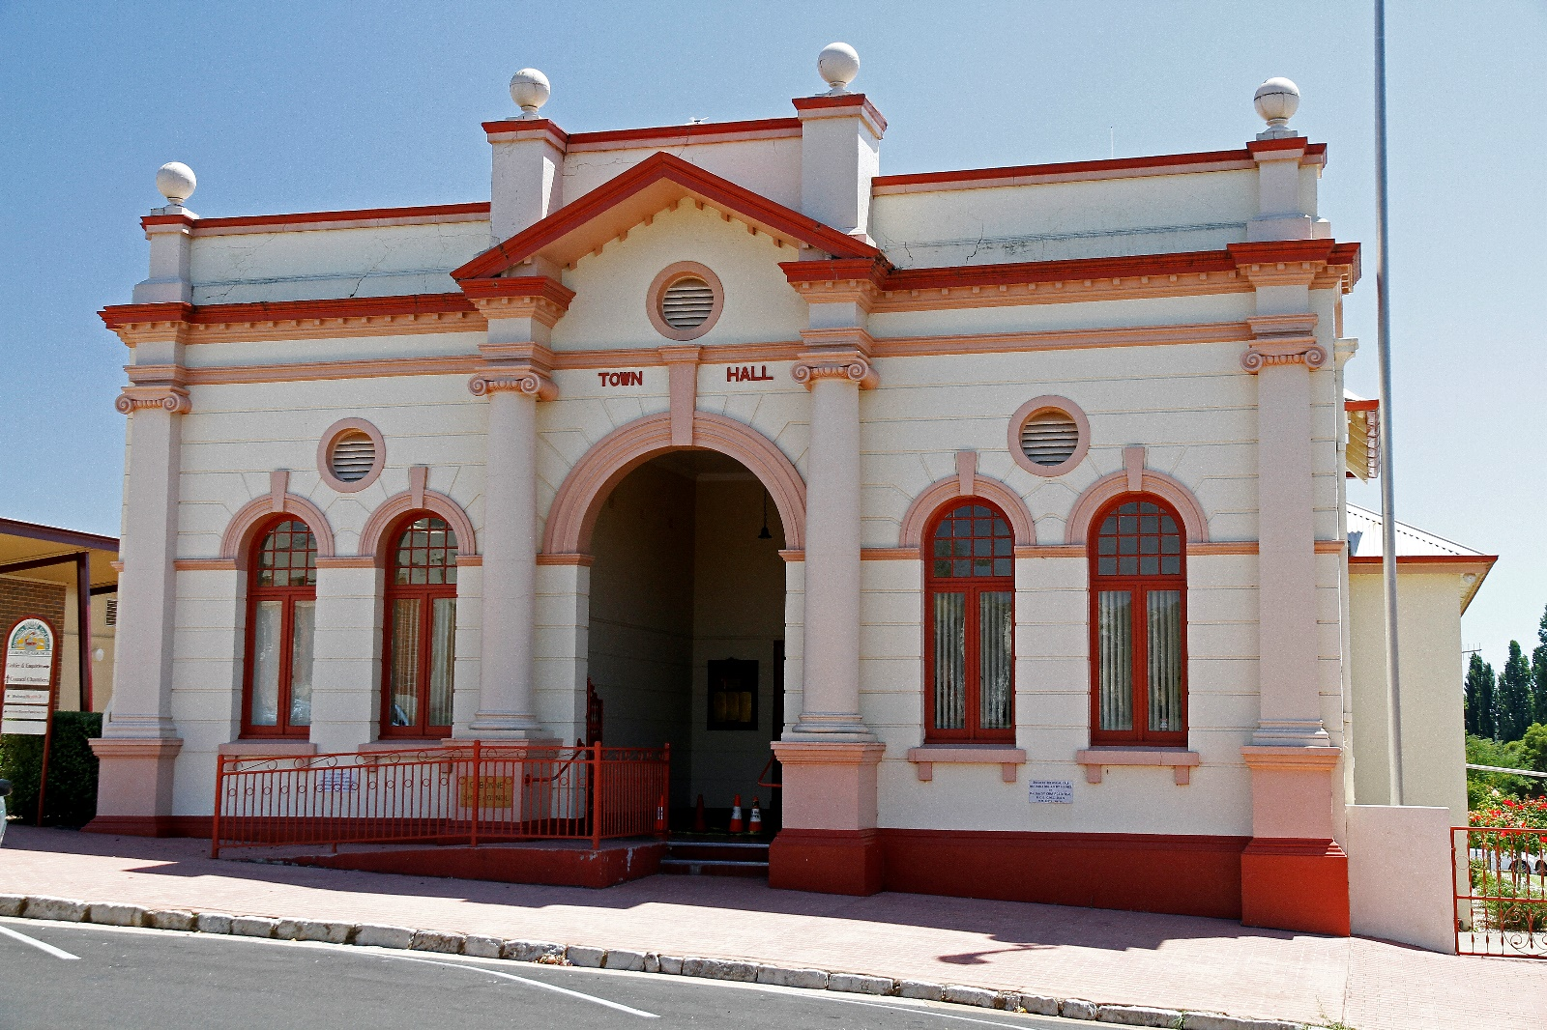

Contract 1033172 - Project Management Services

Request for Tender (RFT)

CONTENTS

CONTENTS 2
1. SUMMARY 3
2. BACKGROUND 4
3. SCOPE OF WORK 5
4. PROJECT MANAGEMENT REQUIREMENTS 8
5. VARIATION TO SCOPE OF WORKS 9
6. CONDITIONS OF TENDER 9
7. Conditions for Participation 12
8. SCHEDULES FOR COMPLETION 15

SUMMARY

Cabonne Council is seeking Project Management Services to manage the turn-key completion of the following Primary Projects:

- Molong Community Hall, Library & Community Learning Centre.
- Eugowra Puzzle Flat Creek Flood Levee

Other projects requiring similar expertise may also arise during the term of engagement and would be negotiated with the successful tenderer as a separate scope at the nominated hourly rate .

The project manager will be required to manage all aspects of work to progress the primary project to meet the nominated milestones. Each project will have a project sponsor to which the Project Manager will directly report for the particular project.

Expertise with the Project Management of Public Buildings, Flood levees, Contracts, Council processes including planning, tendering, safety and information handling, and the acquittal process associated with State and Federal Grants would be advantageous.

Based on other projects it is anticipated that the quantum of work would average approximately four (4) days per week over an estimated two (2) year period however tenderers are to use their own expertise in determining the hours, travel and expertise required to deliver the primary projects.

Hours of work may on some occasions extend into weekends subject to the contractors construction schedule. The successful Project Manager (PM) will be required to demonstrate a degree of flexibility due to possible minor scope adjustments during the project.

Subsidiary projects may be negotiated at the nominated hourly rate.

In general the PM will be required to be available to attend the site within four (3) hours should issues arise.

BACKGROUND

2.1 Cabonne Shire

Cabonne Council is located in the Central Tablelands of New South Wales, approximately 290 kilometres west of the Sydney CBD. The area is bounded by the Dubbo Regional Council, Narromine Shire Council and the Mid-Wester Regional Council areas in the north, the Bathurst Regional Council area in the east Orange City, Blayney Shire and Cowra Shire in the south, and Forbes Shire and Parkes Shire in the west.

Cabonne Shire is represents over 13,800 people covering an area of more than 6,126 sq kms comprising the towns and villages of Molong, Canowindra, Manildra, Eugowra, Yeoval, Cumnock, Cudal, Cargo, Mullion Creek, Borenore and Nashdale. The area is home to the site of Australia’s first gold rush and is also famous for ballooning, food and wine, agriculture and mining.

The council has administration offices in Molong and Cudal, depots in Molong, Cudal, Orange and Canowindra, a water treatment plant in Molong and sewer treatment plants in Molong, Canowindra, Manildra, Cumnock, Yeoval, Cudal and Eugowra. The council also runs seven outdoor swimming pools, nine community halls and several showground and sporting pavilions throughout the shire.

Council has four key divisions

- Corporate & Finance Services including finance, human resources, risk and administration and governance services.
- Engineering and Technical Services comprising planning, investigation, design, construction and operation of infrastructure assets - roads, bridges, stormwater drainage structures, buildings, water, sewerage, utilities, noxious weeds including plant fleet management..
- Environmental Services including planning, health and building, waste services, ranger services and cemetery management.
- Community Engagement & Development including economic development, communications and media, tourism

The annual operating budget is just over $47 million and an assets value of $634m

SCOPE OF WORK

Council wishes to engage a project manager (PM) to assist in the delivery of the Primary Projects (PP) in Cabonne Shire. The projects which comprise the Primary Projects are outlined below;

3.2 Molong Community Hall, Library & Community Learning Centre

Project Objective, Overview | Cabonne Council has secured funding to construct the Molong Community Hall, Library and Community Learning Centre which will deliver an expanded, accessible and modern community building.  The new architecturally designed space will incorporate  - Community hall facilities to provide for public meetings and community functions  - Indoor and outdoor areas with capacity for meetings, study, technology connection and delivery of community-centric programs.  - An exhibition area integrated with the public space  The project includes demolition of existing buildings and re-build to provide safe and user-friendly access and facilities to all members of the community.
Total Project Cost | Approximately $6 Million
Funding Source: | NSW State Government Regional Cultural Fund  Cabonne Council
Key Deliverables | The project manager would be required to:  - Undertake an Enquiry by Design to develop a preliminary structure plan and refine and test the plan against the vision and principles of the Council and community and aligning with Council’s Community Strategic Plan and Delivery Program  - Completion/review of the final detailed design  - Prepare/review tender documents for the delivery of the project These may include but are not limited to civil, structural, Geotechnical, quantity surveying, landscaping, technology services as required for the delivery of these projects.  - Tendering and contract negotiation  - Supervision of the construction/demolition and contract management.  - Coordination of the all the approvals from the relevant government departments and other related organisations which are necessary for the delivery of the project.  - Consultant and contract management  - Stakeholder and community consultation  - Overall project management.  - Reporting and acquittal of the Grant funding at key milestones
Key Reporting Milestones | To funding body as per funding agreement
Key Milestones | Stage One: Project Scope & limitation | Project concept & brief | 4 weeks from appointment
 | Stage 2: Project Design | Complex design (enquiry by design) | By 30 June 2020
 | State 3: Project delivery | Building completed | 30 June 2021
 | Stage 4: Project Closure | Handover of asset and project completed | 30 July 2021

3.3 Eugowra Puzzle Flat Creek Flood Levee
Project Overview | The proposed works involve an upgrade to the existing levee and construction of a new levee within the 'gap'. The construction to fill in approximately 1km gap in the existing levee on the Puzzle Flat Creek at Eugowra will prevent flood water diverting through the gap in the levee and inundating the eastern section of Eugowra. A complete levee will help to retain flood water within the channel of the creek and divert flood water around the village. The existing levee has gaps and is inadequately sized and as such does not protect the community from flooding. The proposed new levee will fix the gaps and raise the existing levee to a more suitable height.
Total Project Cost | $2,341.210
Funding Source: | $1,560,806 Office of Environment & Heritage Floodplain Management Program  Cabonne Council – balance
Key Deliverables | The project manager would be required to:  - Undertake review of the existing design.  - Review of the tender documents if required for the delivery of the project These may include but are not limited to civil, structural, Geotechnical, quantity surveying, landscaping, technology services as required for the delivery of the project.  - Tendering and contract negotiation  - Supervision of the construction and contract management.  - Coordination of the all the approvals from the relevant government departments and other related organizations necessary for the delivery of the projects.  - Consultant and contract management  - Stakeholder and Community consultation  - Overall project management.  - Reporting and acquittal of the Grant funding at key milestones
Key Reporting Milestones | To funding body as per funding agreement
Key Milestones | Stage One: Review of the existing design | Review of the existing design. | Within two weeks of the appointment.
 | State 2: Necessary approvals from relevant department and organisation/property owners for the construction activiites. | Private land, railway land, Crown land acquisition and others as required. Land acquisitions are in progress at the moment.. | 30 November 2019
 | Stage 3: Selection of competent contractor | Tendering and contract negotiation. | 30 September 2019
 | Stage 4: Project delivery | Construction and contract management of flood levee, drainage and road works including testing and hand over. | 31 May 2020

PROJECT MANAGEMENT REQUIREMENTS

In assessing this submission, Council is more interested in the proposed individual’s ability and availability to satisfy the requirements of this RFT. Should the individual engaged not be able to perform the duties until completion of the project Council may choose to terminate the consultancy and procure another Project Manager.

The Project Manager needs to be able to demonstrate the following competency and experience:

- High degree of proficiency in project management with track record of delivering infrastructure projects on time and within budget
- Project Management of public buildings and flood levees in local government environment
- Contract administration
- Developing, managing and assessing tenders
- Superintending major building design & construction contracts of a similar nature to the projects
- Experience in obtaining relevant approvals for building/construction works
- Ability to mentor council staff and work within council policies, procedures and legislation
- Innovative problem solver
- Experience with accredited systems such as WHS AS4801, Quality ISO 9001 and Environmental ISO 14001.
- Good written and oral communication skills including ability to create non-standard reports
- Stakeholder and user (community) consultation skills
- High level financial management and budgetary control
- Availability and ability to attend on site at short notice
- Commitment to risk management
- Political sensitivity

SUPPORTING INFORMATION FROM TENDERERS

The Tenderer will provide evidence
- Copy of Certificate of Currency for Public Liability Insurance to the amount of $10 million
- Copy of Certificate of Currency for Professional Indemnity to the amount of $2 million
- Copy of Work, Health & Safety (WHS) Plan
- Example of project plan and brief of similar project.

Hourly rates and all likely disbursements need to be outlined on Schedule B.

Council will provide office space, access to networks and systems, administrative support.

The successful consultant will need to operate within, and comply with, council’s Enterprise Risk Management framework, associated policies and procedures and maintain confidentiality.

VARIATION TO SCOPE OF WORKS

If during the engagement there are variations to scope of works, including timelines, budget, risk the Project Manager must advise the Project Sponsor or his delegate immediately. Work that would impact of cost of the project or goes above the original estimate of engagement must be approved by the Project Sponsor or his delegate prior to undertaking the work.

CONDITIONS OF TENDER

6.1 Lodging Your Tender

Tenders are to include:

- Completion of Schedule A of this request for tender (RFT).
- A cover letter outlining relevant experience and qualifications.
- A proposal outlining how you would approach the “Primary Projects”, including full fee structure (payment milestones) and project timeline.
- Completion of Schedule B of this request for tender for costs associated with any project or works outside the scope of the Primary Project brief.
- References to similar works preformed.
- Submission of electronic copy of the proposal.
- Copies of relevant insurances.
- Name and contact details of two referees
- ABN (if applicable)

RFT must be clearly marked “RFT Project Management Services” and lodged to reach Cabonne Council by 18th of September 2019 by the following methods:

Online (preferred) in the electronic tender box at www.tenderlink.com/cabonne
By Mail General Manager, Cabonne Council, PO Box 17, Molong, NSW, 2866
By Email Council@cabonne.nsw.gov.au
In Person Council office - 101 Bank Street, Molong.

6.2 Tender Closing date & Validity period

Council may reject any Tender not received by the Closing Date and Time. Lodgement of Tenders by the closing date and time is entirely the responsibility of the Consultant.

Consultants must lodge their proposal by 18th of September 2019.

Proposals must be valid for 60days after lodgement.

6.3 Pricing

Payments will be made upon receipt of monthly invoice containing the description of the works/services hours and cost.
The prices in the tender must:

- Be inclusive of Goods and Services Tax (GST) and any other applicable taxes and duties.
- Include, without limitation, delivery, site allowances, unloading, packing, marking all applicable levies and duties, taxes and charges. Any charge not stated in the tender, as being additional will not be allowed as a charge for any transaction under any resultant Agreement;
- Treatment of travel time should be clearly articulated in the tender;

6.4 Variation of Tender

At any time prior to the closing date and time, Council may accept a variation to a submitted PM Tender, subject to the following:

- By providing Council with further information by way of explanation or clarification; or
- By correcting a mistake or anomaly.

Such a variation may be made either:

- At the request of Council; or
- With the consent of Council at the request of the Consultant, but only if, in the circumstances, it appears to Council reasonable to allow the Consultant to provide the information or correct the mistake or anomaly.

If a tender is varied in accordance with this clause, Council will notify in writing all other Consultants who’s Tenders have the same or similar characteristics as the varied Tender, and provided them with the opportunity of varying their Tender in a similar way.

Council will not consider a variation of a Tender made under this clause if the variation would substantially alter the original Tender. Any variation in scope of work, or delays to project timelines that may incur additional costs beyond what was estimated in the original tender proposal must be advised and approved by the Project Sponsor or his delegate prior to the undertaking the hours.

6.5 Withdrawal of Tenders

Consultants may withdraw their tender at any time prior to acceptance.

6.6 Questions about Tenders

If the consultant has any doubt as to the meaning of any part of the Request for Tender or the scope of the work to be completed, then the consultant should seek to clarify any point of doubt or difficulty with Council before submitting the Tender.

All enquiries regarding this tender must be directed to:

Brad Byrnes  General Manager  Cabonne Council  PO Box 17 (101 Bank Street Street)  MOLONG NSW 2870  E: Bradley.byrnes@cabonne.nsw.gov.au  P: 02 6392 3200 | Or | Bob Cohen  Director of Engineering and Technical Services  Cabonne Council  E: robert.cohen@cabonne.nsw.gov.au  P: 02 6390 7100
Or
Surendra Sapkota
Manager Technical Services
Cabonne Council
E: surendra.sapkota@cabonne.nsw.gov.au
P: 02 6390 7100

6.7 Assessment of Tenders

Cabonne Council will assess all Tenders against the following selection Criteria:

- Contracts will be evaluated on:
  - price of specific tender
  - past performance in delivery of infrastructure projects
  - capacity and capability of contractor
  - availability (timing of work)
  - work methodology
- The tender is to show a full breakdown of costs as per the schedule of rates – GST inclusive.
- Council is not bound to accept the lowest or any tender.
- Petitioning of Councillors and Council staff is prohibited.
- Certificates of Currency for Insurances

6.8 Changes to this Request for Tender

Council reserves the right to:

- discontinue the process;
- vary the process to its requirements or the evaluation criteria;
- reject all proposals;
- accept an alternative non-conforming proposal/Tender where the alternative is outlined and will satisfy the project outline beyond as stated.

Council is not:

- bound to accept any proposal;
- obliged to provide any information in relation to its evaluations or decision making process.

6.9 Acceptance of Tender
For the purpose of the Request for Tender, the date of acceptance of the successful Tender shall be the date upon which Council notifies the successful Consultant in writing.

Conditions for Participation

Council expects all Consultants and Contractors to Council to conduct their business with Council in an ethical manner and be aware that they may be subject to public scrutiny by such bodies as the Independent Commission Against Corruption.

Canvassing of Councillors and Council staff (other than Council’s nominated contact staff member/s) at any stage up to and including the acceptance of Tender may automatically disqualify the applicant.

Council shall provide all information that it considers necessary for the preparation of a Tender. Verbal advice given by any Councillor or Officer of the Council shall not be considered in the preparation of a Tender.

7.1 Company Status

It is mandatory that a company tending a proposal:

- Is a legal entity; and
- has a registered Australian Business Number (ABN) and
- Is registered for the Goods and Services Tax with the Australian Taxation Office.
- Has public liability, professional indemnity and workers compensation insurance

7.2 Work Health and Safety

Any contractor to Council is subject to the requirements of the NSW Work Health and Safety Act 2011, and to work under Councils Work Health and Safety System. Contractors must hold their own workers compensation insurance cover and are not deemed employees of council and therefore not covered by council insurances.

7.3 Council’s Code of Conduct

Council has adopted a ‘Code of Conduct’ (Code) policy with the aim of ensuring that functions are undertaken efficiently, impartially and with integrity. A copy of the Code is available at Council’s web site or on request by contacting the Nominated Contact.

In addition to the terms of the Code, a service provider must not engage in any unethical or uncompetitive activity or attempt to improperly influence the evaluation of proposals including the canvassing of Councillors or staff of the Council by Vendors or their representatives.

7.4 Invoicing and Payment

Council shall be granted a thirty (30) day account. Invoices should include breakdown of hours worked for the period and separate incidental or travel costs.

The Consultant shall be responsible for providing the official council purchase order reference number on each tax invoice. Payment by council is subject to a valid tax invoice made out to Cabonne Council.

7.5 Insurance

The successful Consultant must hold current insurance policies in accordance with the requirements of the Request for Tender, including (without limitation) public liability, professional indemnity and workers compensation insurance.

7.6 Termination of Agreement by Council

Council reserves the right to terminate whole or part of the Agreement should:

- The PM services prove to be unacceptable quality, as defined by Council.
- The PM fails to adhere to relevant Council policies and plans, or to obey reasonable directions from Cabonne Council.
- The PM fails to deliver services according to specifications in the Request for Tender and within scope, timelines and budget of projects.

The Consultants only entitlement to payment shall be the amount of the costs covering services received up to the date of termination notice less any previous payments.

If the Consultant becomes bankrupt, insolvent or enters into a scheme or arrangement with its creditors, Council may terminate this Agreement by written termination notice addressed to the Consultant.

7.7 Termination by the Consultant

If the Consultant becomes insolvent or enters into a scheme of arrangement with its creditors, the Consultant should forthwith terminate this Agreement by written notice addressed to Council.

The Consultant may terminate the Agreement by written termination notice addressed to the General Manager, should Council:

- Fail to pay the Consultant in accordance with the Agreement; or
- Commits a substantial breach of the Agreement.

SCHEDULES FOR COMPLETION

SCHEDULE A – PRIMARY PROJECTS

TO BE COMPLETED BY CONTRACTOR

Name of person, firm or company Tendering:
hereby quote to perform the works for: |  | Project Management Services – Primary Projects (PP)
All Goods and Services Tax is to be included separately in the specified "GST" line item.
Note: Costs can be broken down into the four project states or an overall total sum can be provided.
ITEM  NO | ITEM DESCRIPTION |  | Estimated  QTY | UNIT |  | RATE $/UNIT |  | AMOUNT $
PP-1 | Molong Community Hall, Library & Community Learning Centre |  |  | Hours
PP-2 | Eugowra Puzzle Flat Creek Flood Levee |  |  | Hours
Sub-total excluding GST (A)
GST (B)
Total (A) + (B)
Disbursements (estimated) |  |  |  |  |  |  | Rate  (Including GST)

SCHEDULE B – FEES

Name of person, firm or company Tendering:
hereby quote to perform the works for: | Project Management Services – Subsidiary Projects (SP)
All Goods and Services Tax is to be included separately in the specified "GST" line item.
Outline the list of fees charged in the delivery of additional projects (outside the scope of the two principle projects).

Base hourly rate (GST inclusive)

Travel

Disbursements

