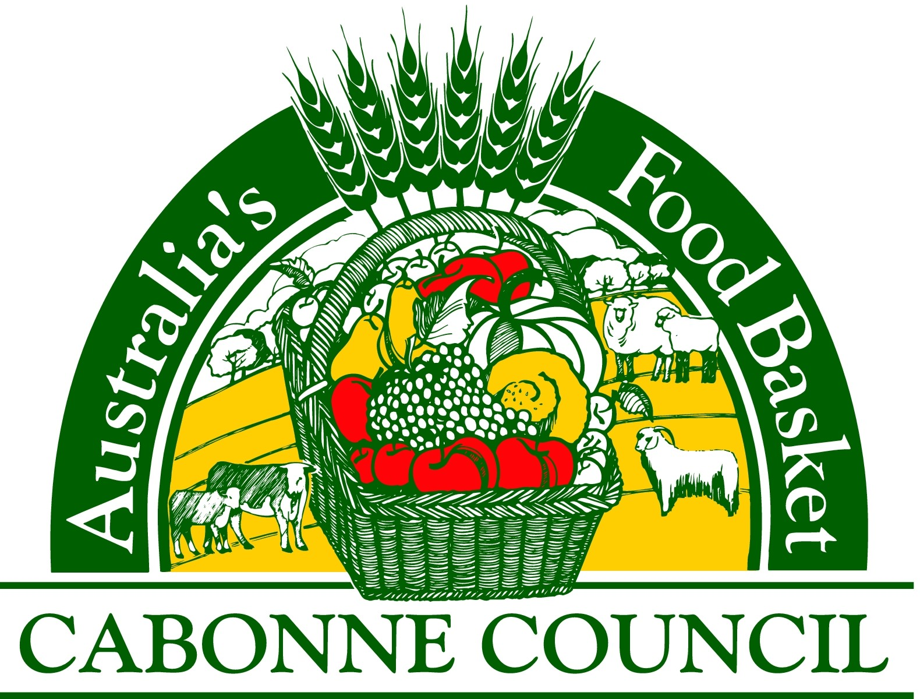

Molong Floodplain Management Advisory Committee

Expression of Interest (EOI) Form

Cabonne Council is seeking two (2) individuals to be appointed to the Molong Floodplain Management Advisory Committee.
The Committee aims to:

- Provide a forum for the discussion of technical, social, economic, environmental and cultural issues; and
- Create the opportunity for the views of key stakeholders to be identified and captured through the development and implementation of floodplain management plans

The objectives of the Committee are:
- State Government policy for floodplain risk management
- Flood studies and network analysis
- Floodplain risk management studies, including priorities for management initiatives
- Floodplain risk management plan implementation, including oversight of floodplain risk mitigation works projects
- Priorities for future study and analysis
- Other matters as outlined for Floodplain Risk Management Committees as pertained within the NSW Governments Floodplain Development Manual

If you are interested in applying for a position on this committee, please complete the details (overleaf). Further information can be obtained by contacting Councils Deputy General Manager, Infrastructure on 63907100.

- Details
Name of Applicant
Address  House Number/Name/ PO Box |  | Street/Road
City |  |  |  |  | State |  |  |  | Postcode
Telephone |  |  | Fax
Email
The committee is seeking local community representatives that can demonstrate they:
- Maintain a broad interest or technical understanding of floodplain management
- Have a commitment to floodplain management for the Molong township
- Are a resident or business person living or working in or near a flood prone area

Please detail what qualities and experience you will bring to the committee, noting the above criteria.

I wish to register my interest in being part of the Molong Management Advisory Committee.
Signature

Applications are to be returned to Cabonne Council email: council@cabonne.nsw.gov.au or post: PO Box 17 Molong NSW 2866, by Sunday 21st June 2020.

