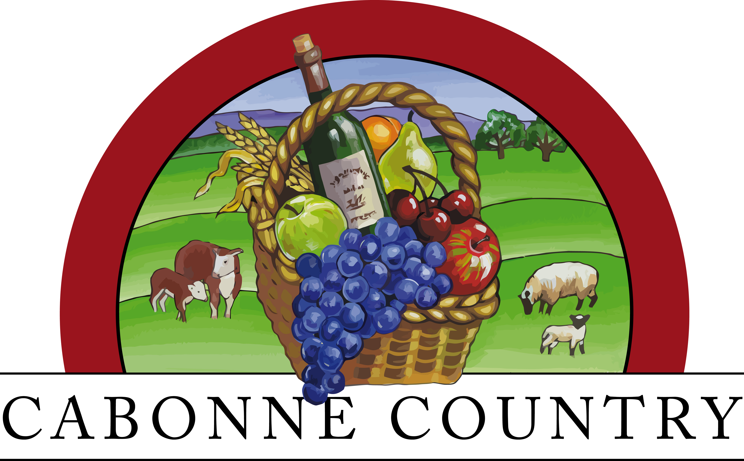

Cabonne Country Tourism Advisory Committee

EOI

Application Form

Cabonne Council is seeking a minimum of 7 individuals to be appointed to the Cabonne Country Tourism Advisory Committee for the duration of 2 years.
The Committee aims to “To facilitate the development of tourism to and within the Cabonne Country”.
The objectives of the Committee are:
- To provide input to the design of the Cabonne Council Tourism Plan – this is the information gathering phase:
- understand the importance of tourism to the area now & its future potential,
- assess tourism infrastructure & how it can be improved,
- what assistance is required for groups for tourism activities,
- partnerships and alliances which can be formed to facilitate tourism in the area
- identify target markets in the various segment that make up Cabonne (food & wine, larger towns, small villages)
- analyse current tourism statistics (ie establish the starting point), identify trends & set measurable visitation objectives

- Based on the information sourced in the design phase, to provide input to the Tourism Plan – its Key Objectives, strategies for implementation & actions (projects) for the years ahead

- To advise and implement the actions / projects listed in the Tourism Plan.

- To advise on methods for evaluating the actions implemented, review the evaluation and set actions/ projects for the ongoing delivery of tourism.

If you are interested in applying for a position on this committee, please complete this form and return to Council by Friday 31 May 2019.
Further information can be obtained by contacting Councils Promotion and Tourism Officer or Economic Development Manager on 6392 3201.
Application
- Details
Name of Applicant
Organisation Address  House Number/Name/ PO Box |  | Street/Road
Town |  |  |  |  | State |  |  |  | Postcode
Telephone/ Mobile |  |  | Fax
Email
Are you a resident and or your business/ represent a community groups is located / provides service to Cabonne Shire LGA? ◻ yes ◻ no

What is your business or community group represented / name?_
_____________________________________________________________________________________

Cabonne Country Tourism Advisory Committee meetings will be held monthly on a Tuesday at 6pm. Meeting venues across the Shire will be utilised to showcase each town. To be eligible for the Advisory Committee, you are required to arrange your own travel to these meetings. Are you able to meet this requirement? ◻ yes ◻ no

What attributes will you bring to the Cabonne Country Tourism Advisory Committee? Please make reference to your experience and achievements, focusing on the skill set of market experience & promotion, event management, plan implementation, research & surveying, information technology, creativity, grant writing, networking & life skills. Applicants are encouraged to seek assistance from Council staff if having difficulty with this question.

What would you like to see the Committee to achieve in the next 12 months?

I wish to register my interest in being part of the Cabonne Country Tourism Advisory Committee.
Signature

Applications are to be returned to Cabonne Council email: council@cabonne.nsw.gov.au or post: PO Box 17 Molong NSW 2866, by Friday 31 May 2019.

