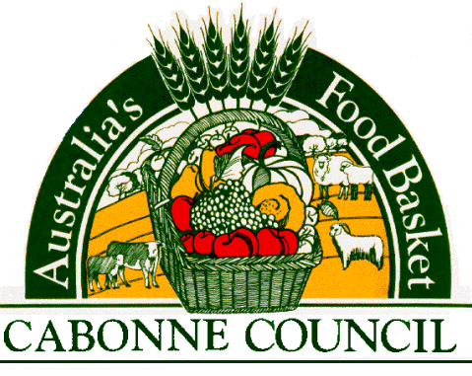
Alcohol Control in Public Places

Policy
- Document Information
Version Date  (Draft or Council Meeting date) | 28 May 2019
Author | Manager Technical Services
Owner  (Relevant director) | Director of Engineering & Technical Services
Status –  Draft, Approved, Adopted by Council, Superseded or Withdrawn | Draft
Next Review Date | Within 12 months of Council be elected
Minute number
(once adopted by Council)
- Summary
Council has established alcohol free zones and alcohol prohibited areas and resolved that no alcoholic beverage may be consumed or brought into the enclosed area surrounding any of the public swimming pools.
- Approvals
Title | Date Approved | Signature
Director of Engineering & Technical Services
- History
Minute No. | Summary of Changes | New Version Date
10390 | Initial Alcohol - Consumption within Enclosed Area policy | 19/03/90
10/02/17 | Readopted by Council | 15 February 2010
03/02/25 | Initial Alcohol Free Zones & Alcohol Prohibited Areas policy | 17/02/03
10/02/17 | Readopted by Council | 15 February 2010
13/03/11 | Combined into Alcohol Control in Public Places policy | 19 March 2013
13/09/30 | Readopted as per s165(4) | 17 September 2013
18/05/20 | Author title updated. Readopted as per s165(4) | 22 May 2018
 | Amendment in clause 11 when referencing Alcohol Free Zones to include “Implementation of these zones would not prevent the consumption of alcohol in any footpath dining areas that have a liquor licence covering the footpath dining areas”.
- Reason
To promote the use of roads, footpaths and carparks in safety and without interference from street drinkers and in instances of malicious damage to property, littering, offensive behaviour or other crimes Council established Alcohol Free Zone and Alcohol Prohibited Areas as well as prohibiting possession and/or consumption of alcohol in public pools.
- Scope
Alcohol Free Zones include public places in Canowindra and Molong such as public roads or car parks on public or Crown land. The alcohol prohibition in public pools relates to Council owned or managed swimming pools.
- Associated Legislation
Local Government Act 1993
- Definitions
Alcohol Free Zone - is an area that has been established by a council in New South Wales where drinking alcohol is prohibited.
Alcohol Prohibited Areas - apply to all the parks, reserves and ovals signposted as alcohol prohibited.
Public Pools - refers to swimming pools owned or managed by Council.
- Responsibilities
  - General Manager
The General Manager is responsible for the overall control and implementation of the policy.
  - Directors and Managers
Directors and Managers are responsible for the control of the policy and procedures within their area of responsibility.
- Related Documents
Document Name | Document Location
- Policy Statement
Alcohol Consumption within Enclosed Swimming Pool Areas
No alcoholic beverage may be consumed or brought into the enclosed area surrounding any of the public swimming pools within the Council area, with the exception and by written request and from community based (fund raising) organisations and each application to be judged on its merits by full Council.
Alcohol Free Zones & Alcohol Prohibited Areas
Council will establish alcohol free zones in Molong & Canowindra for the allowable periods at:
- Molong – Bank Street from Edward Street to the Mitchell Highway
- Canowindra – Gaskill Street from Ferguson Street to Tilga Street
- Canowindra – the area from Gaskill Street to and including the Swinging Bridge; and
Alcohol Prohibited Areas at:
- Canowindra – Morris Park
- Molong – Village Green
Implementation of these zones would not prevent the consumption of alcohol in any footpath dining areas that have a liquor licence covering the footpath dining areas.

