Cabonne Council Strategic Policy
DRAFT SEWER POLICY

Document Information
Version Date  (Draft or Council meeting date) | 23/02/2021
Author | Manager Water and Waste
Owner  (Relevant Executive) | Deputy General Manager – Cabonne Infrastructure
Status  (Draft, Approved, Adopted by Council, Superseded, or Withdrawn) | Draft
Next Review Date | Within 12 months of Council being elected
Minute Number
(once adopted by Council)

Summary
This policy outlines the responsibilities related to the various sewer schemes within the Cabonne Local Government Area.

Approvals
Title | Date Approved | Signature
Deputy General Manager – Cabonne Infrastructure

History
No. | Minute Number | Summary of Changes | Impact on this policy | New Version Date
1 | 00/04/21 | Canowindra Sewerage Scheme | Included | 17/04/00
2 | 00/08/52-8 | Capital Contribution Payments – Eugowra and Canowindra Sewerage Schemes | Included | 21/08/00
3 | 99/10/14 | Cudal Sewerage Scheme | Included | 18/10/99
4 | 01/02/23-6 | Eugowra Sewerage – Additional Cost of House Connections due to Flat Grades | Excluded | 19/02/01
5 | 01/06/35 | Eugowra Sewerage - Connection | Excluded | 18/06/01
6 | 00/06/22 | Eugowra Sewerage – Headworks Fees | Excluded | 19/06/00
7 | 93/6/98-9 | Sewer Main Extension – Rural 1(c) Zones | Excluded | 07/06/93
8 | 91/4/84-10 | Sewer Main Extension | Included | 15/04/91
9 | 2010/02/17 | Combined into one policy and adopted by Council | Items No. 1, 2, 3 and 8 are Included. No. 4, 5, 6 and 7 are excluded. | 15 Feb 2010
10 | 13/06/21 | Comprehensive review and update to current practices |  | 25 June 2013
11 | 13/09/30 | Readopted as per s165(4) |  | 17 September 2013
12 | 16/02/22 | Mains Subsidy Clause amended with a cap on the council’s $ contribution. Author of policy also updated | Variation to clause | 23 February 2016
13 | 18/07/14 | Readopted as per s165(4) |  | 24 July 2018
14 |  | Comprehensive review, update to align with fees and charges. Note Eugowra and Canowindra Capital Contribution Scheme end.

Objective of the Policy
The objectives of the Sewer Policy are as follows:
1. To ensure CSP 5.3 Sustainable waste management practices are in a place across Cabonne;
2. Protection of public health;
3. Protection of the environment and State’s water Resource;
4. Protection of Cabonne sewage scheme assets;
5. To provide clear direction on the responsibilities towards the availability and maintenance of sewer mains
6. To provide Council with clear direction on the appropriate application of all sewer fees and charges;
7. To provide clear direction on conditions where a sewer main may be extended; and
8. To provide clear direction on conditions where a property may be connected to sewer.

Scope
The policy is applicable to all towns within the Cabonne Council LGA that are serviced by a sewage scheme operated by Cabonne Council, which include: Molong; Canowindra; Eugowra; Cudal; Manildra; Cumnock and Yeoval.
This policy is used to determine issues related to sewer main extensions in both the gravity and low pressure sewage schemes
a. Financial responsibility regarding sewer mains extensions
b. Permissibility of sewer main extensions
c. Application for mains extensions
d. Conditions for compulsory sewer connections

Associated Legislation
- Local Government Act 1993
- Water and Sewerage Industry Act 2008
- NSW Plumbing and Drainage Act 2011
- NSW Plumbing and Drainage Regulation 2012
- Protection of Environment Operations Act 1997

Definitions
4 Towns Sewer Scheme | Refers to the sewer schemes of Cudal, Manildra, Cumnock and Yeoval, which operate using the low pressure sewer system.
Access/Availability Charge | Charge that is paid on an annual basis on a property/allotment that is within the village zone and within 75m of a practical connection to a sewer main.  Access charge should not be levied on an allotment that cannot be serviced by sewer due to the terrain.
Boundary kit | The boundary kit is used to isolate on property connections from the sewer mains in low pressure sewer schemes. The assembly consist of the boundary box, isolation valve, check valve and inspection tee piece assembly.
Boundary Shaft | Is the equivalent of a boundary kit used in gravity sewage schemes.
Community use | A non-profit facility that is used for the benefit of the community. This includes showgrounds, sports ovals, public buildings such as community halls and libraries.
Commercial use | Commercial developments which include golf clubs, motels, hotels, hospitals.
Customer Sanitary Drain | Gravity sewer connecting the property wastewater discharge points to the PSU.
Developer Charges | Are upfront charges that a Local Water Utility can levy under section 64 of the Local Government Act 1993 to recover part of the sewage infrastructure cost incurred from servicing new developments or additions. Developments introduce new demand for services and it is equitable that new developments pay a contribution to cover the capital cost of new infrastructure.
Fees and Charges | Refer to Councils Current Fees and Charges.
General residential | Designated village zone based on the current LEP.
Gravity sewage scheme | Conventional sewer system which relies on gravity to transport waste water to the sewage treatment plant. Pump stations are used to provide sufficient dynamic head to transfer waste water to the sewage treatment plant. Gravity sewage schemes in Cabonne Council consist of Molong, Canowindra and Eugowra.
LGA | Local Government Area.
Low pressure sewage scheme | Low pressure sewer schemes are the sewage schemes used to service the towns of Cudal, Manildra, Cumnock and Yeoval (4 Towns Sewage Scheme).
Low pressure sewer unit (PSU) | Low pressure sewer unit (PSU) are small waste water pump stations used to operate the low pressure sewage schemes in the 4 Towns Sewer Scheme. Each low pressure pump system would consist of a pump, waste water tank, level sensor and control panel.
LEP | Local Environmental Plan
Original 4 Towns Village Zone/Original designated village zone | The original 4 Towns Village Zone refers to the sewer schemes of Cudal, Manildra, Cumnock and Yeoval where all the property owners received 60% federal funding for their sewer connection. Prior to this, the towns were not serviced by sewer. Note that vacant land owners in the Cudal village zone did not pay any pre-construction levy, which was paid by vacant land owners in the village zones of Manildra, Cumnock and Yeoval.
Occupied land in original scheme rateable | These are developer charges and refer to allotments in the 4 Towns Sewer Scheme where owners paid a Pre Construction Levy. The allotments were within the original designated village zone during the time of sewer scheme introduction. This does not apply to new subdivision that may occur within the boundaries of the original designated village zone.
Occupied land not in original scheme | These are developer charges and refer to allotments in the 4 Towns Sewer Scheme where owners did not pay a Pre Construction Levy because they were outside the designated village zone during the time when the scheme commenced.
Pre-construction levy | This is the amount paid by each property owner in the 4 Towns Sewer Scheme to help fund the scheme. The pre-construction levy was paid annually for a period of 10 years before commencement of construction of the scheme.  - Cudal, Cumnock and Yeoval paid the same pre-construction levy annually.  - Manildra paid a reduced levy over a longer period but at a reduced rate.
Pressure Reticulation Sewer | Network pressure mains located outside the property boundary.
Property Discharge Line | Pipeline connecting the property boundary kit to the PSU.
Sewer main extensions | Sewer mains are extended to service a previously unserviced area within the village zone/general residential area.
Sewer connection | A sewer connection connects the property to Council’s sewer asset.
Vacant Land | Land that is unoccupied by a building (residential or commercial)
Vacant land sewer rates | Rates that are paid on a vacant block of land that must connect to sewer if required under the LEP.
Vacant land not in Original Scheme | Synonymous with unoccupied land not in the Original Scheme. This refers to land that was outside the boundaries Original 4 Towns Sewer Scheme at the start of the scheme
Vacant land in Original Scheme | Synonymous with unoccupied land the in Original Scheme. This refers to land that was within the boundaries Original 4 Towns Sewer Scheme at the start of the scheme
Vacant land pre-construction levy | This is the levy paid for vacant allotments within the boundaries of original scheme (refer to Appendix A for relevant documents). Property owners who have paid the levy, which was approximately half the full pre-construction levy, would only have to pay a “catch up” levy for a sewer connection.  Cudal was the only town which was not involved in Vacant land pre-construction levy, which meant that full head works cost would apply for any existing allotments in the Original Scheme. The applicable fees and charges are stipulated in this document.
Vacant land “catch up” fee | The vacant land “catch up” fee is the applicable developer charge on an allotment in the original scheme of the 4 Town Sewer Scheme whereby the owner had paid the full vacant land pre-construction levy. This would apply to residents in Manildra, Cumnock and Yeoval. It will not apply for residents in Cudal as owners of allotments in the original scheme had not paid vacant land pre-construction levy.
Industrial use | Business for commercial gain.

Responsibilities

General Manager
The General Manager is responsible for the overall control and implementation of the Cabonne Sewage Scheme.

Deputy General Managers and Department Leaders
Deputy General Managers and Department Leaders are responsible for the control of the policy and procedures within their area of responsibility.

Related Documents
Document Name | Document ID
Cabonne Pressure Sewer Guidelines | 484160
Liquid Trade Waste Policy | 936249
Request for Reduction in Water and/or Sewerage Consumption Costs Policy | 1012465
Loans – Sewerage Connection Policy | 931358

Policy Statement

Table of Contents
11.1 Overview 6
11.2 Sewer Mains Extensions 6
11.3 Connections 7
11.4 Ownership and Maintenance Responsibilities 8
Gravity Systems 8
Low Pressure Systems 8
11.5 Availability Charge 10
11.6 Loans 11
11.7 Appendix A 11

  - Overview

There are 7 sewer schemes in Cabonne. These are shown in Table 1.
Table 1 Sewer Schemes within Cabonne

1. Molong Sewer Scheme

2. Canowindra Sewer Scheme

3. Eugowra Sewer Scheme

4. Cudal Sewer Scheme

5. Manildra Sewer Scheme

6. Cumnock Sewer Scheme

7. Yeoval Sewer Scheme

Sewer Schemes 1, 2 and 3 (Molong, Canowindra and Eugowra sewage schemes respectively) are gravity sewage schemes. PSUs may be used in these towns to transfer waste water into Council’s sewer mains. The use of PSUs is permitted where all other forms of waste water management is ineffective or economically unviable, or where PSUs would offer particular environmental, economic and/or social benefit.

Sewer schemes 4, 5, 6 and 7 (Cudal, Manildra, Cumnock and Yeoval) are made up entirely of low pressure sewer systems.

  - Sewer Mains Extensions
The extension of mains may be required in some locations where the existing sewer mains do not extend to the property. In these cases a new sewer main will need to be installed to the property along the most practicable route, noting that in some cases the topography and geology of the land may exclude this. Sewer Mains extensions will be the responsibility of the applicant to fund with Council providing a cost estimate based on a detailed design to be undertaken by the applicant.
In some properties in the Residential areas of Canowindra, Molong and Eugowra it may not be possible to connect a property to the sewer via gravity and a PSU may be used to service the block. In these locations, the ownership and responsibility of the PSU is the responsibility of the property owner.
Sewer mains extensions require the approval of the Deputy General Manager - Cabonne Infrastructure. Before any works are undertaken a detailed design of the sewer main extension must be provided to Council for Approval. Any construction of sewer mains extensions MUST be undertaken in accordance with the current Council standards under the supervision of Council Staff as determined by the Deputy General Manager – Cabonne Infrastructure. When the Sewer main is completed to Council’s satisfaction, the applicant will be formally notified in writing and the new sewer main becomes Council’s responsibility from the date of acceptance.
Council has determined the Sewer zoning to be applicable only within the General residential area of the Villages of Molong, Canowindra, Eugowra, Cudal, Manildra, Cumnock and Yeoval. Cabonne Council will generally not permit properties outside of its defined sewerage catchments to connect to a reticulated sewer scheme. Connection of properties outside of the defined sewerage catchments will only be permitted where there is an environmental or health issue with an existing on-site system such that Council issues an order for the property to connect to reticulated sewerage under section 124 of the Local Government Act 1993. Such orders can only be issued on a property within 75 metres of an existing Council Sewerage main.
Where Council permits a property outside of the defined sewerage catchments to connect to reticulated sewerage the following conditions will apply:
- All plumbing shall be in accordance with the provisions of the Local Government Act and the Plumbing Code
- The sewerage connection shall be considered a “private” connection, with the property owner responsible for all maintenance of the connection.
Any Sewer Mains Extension developed to serve land subdivision within the town and village zone may be shared on a 50/50 basis between council and the applicant. Any contribution by Council being limited to a maximum of $5,000 per subdivision dependent upon Council being satisfied that the subdivision is in the interest of immediate residential development. Any contribution will be dependent upon available funds within the Cabonne Sewer Fund in any one financial year, taking into account future asset maintenance and replacement requirements for the sewer fund.

  - Connections
For the Gravity Sewer systems, where a property boundary is directly fronting the Sewer mains, and a connection does not already exist, the property owner will be required to pay a connection fee only. This connection fee only covers the cost of connecting into the mains, it does not include any sewer mains extensions that may be required.
For the Low Pressure Sewer systems, where a property boundary is within 10 metres of the Sewer mains, and a connection does not already exist, the property owner will be required to pay a connection fee only. This connection fee only covers the cost of connecting into the mains, it does not include any sewer mains extensions that may be required.

Developer Charges
Where a residential property is a pre-existing allotment within the General Residential Area, no developer charges are applicable.
Where a new allotment is created via subdivision within the new residential area, Developer Charges are applied to the new allotments in accordance with Council’s current fees and charges.
If an allotment is sewered from outside the General Residential area irrespective of whether it is an existing allotment or a new subdivision, Developer Charges are applicable.

  - Ownership and Maintenance Responsibilities

Gravity Systems
In the gravity sewerage systems within the Villages of Molong, Canowindra and Eugowra, the connection is considered to be the responsibility of the land owner refer to the following diagram.
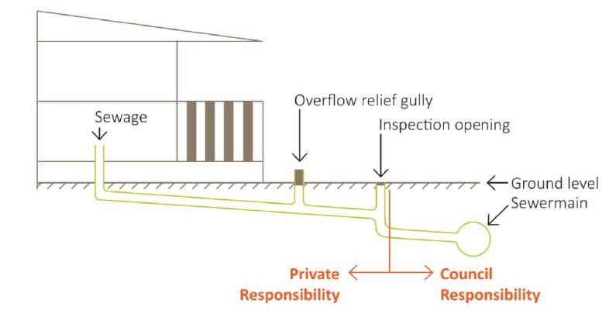

Low Pressure Systems
Molong, Canowindra, Eugowra Sewage Schemes
PSU’s installed in the Sewer Schemes of Molong, Canowindra and Eugowra are owned and operated by the property owner.
The General conditions of the PSU installation are as follows:
- PSU installed on the property shall be in accordance with the latest edition of the Pressure Sewerage Code of Australia and any associated Council documentation
- Inspected and Commissioned by qualified Council staff
- The property owner is responsible for all fees and charges and all costs associated with the installation of the PSU;
- The property owner is responsible for the PSU and all associated pipework upstream of the boundary kit. This includes the following components
  - Pressure Sewer unit
  - Property discharge line/s from the PSU to the property boundary assembly control / alarm panel
  - Property boundary assembly pump control / power cable
  - Boundary kit at the boundary of the property.
For the purposes of this policy all pipes, tanks, pits, pumps, fittings and components of the low pressure sewer system on private property including the boundary kit are the responsibility of the property owner. This includes all repair, maintenance, running costs and replacement as necessary.
All sewer mains downstream of the boundary kit are considered public assets and are the responsibility of Council.
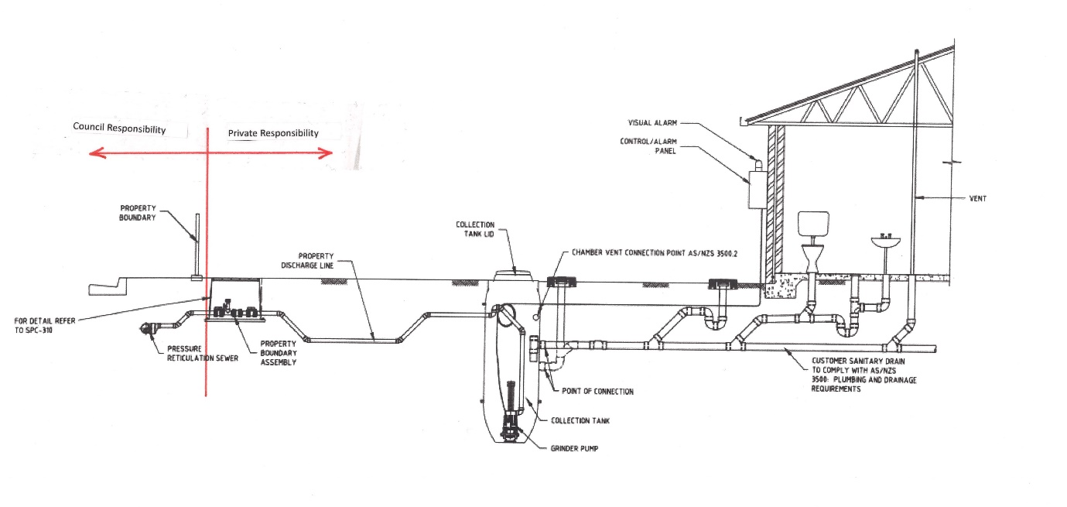
Diagram - Molong / Canowindra / Eugowra Pressure System
Cumnock, Yeoval, Cudal, Manildra (4 Towns Scheme)
Within the villages of the 4 Towns Scheme, the PSU’s in these schemes are Council assets and are owned and operated by Council. Council is responsible for installation and the ongoing operations and maintenance of the PSU’s, including responding to alarms from the PSU’s, pumping out of the Pods, repairing and replacing pumps IF NOT caused by malicious damage or irresponsible use. Noting that in the case of deliberate or malicious damage, or other damage that is not consistent with normal wear and tear the Property Owner may be held responsible for any repairs.

Council’s ownership of the PSU includes the following components:
- Pressure Sewer Unit (PSU)
- Property Discharge line/s from the PSU to the property boundary assembly control/alarm panel
- Property Boundary assembly Pump Control / power cable
The PSU must be connected to the properties electrical switchboard with the property owner being responsible for any maintenance of the electrical cable between the property switchboard and the control/alarm panel as well as for the individual power usage. When installing the PSU, it will be installed as close as possible to the mains.
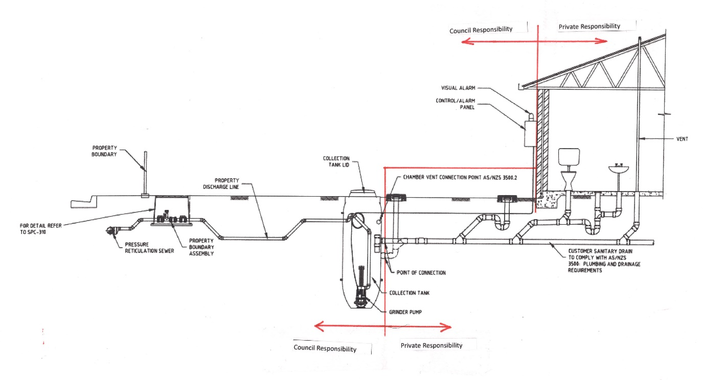
Diagram – 4 Towns Pressure System

  - Availability Charge
All properties within the sewer zone are required to pay the availability charge in accordance with council’s adopted Fees and Charges.
  - Loans
Under certain circumstances Council offers interest free loans to ratepayers for sewerage connection purposes. Refer to Council’s Loans – Sewerage Connection Policy

  - Appendix A
Table 2 Relevant Documents for 4 Towns Sewer Scheme
 | Description | Doc ID:
Cudal Sewage Scheme | List of properties in original scheme | 464266
 | Full Map of original scheme | 465461
 | Street Maps of original scheme | 464505-464528
Manildra Sewage Scheme | List of properties in original scheme | 448985
 | Manildra Sewage Scheme Work as Executed | 478427
Cabonne Low Pressure Sewer Guidelines May 2013 | Guidelines for installation, operating and maintaining low pressure sewer systems | 479166

